Assignment 4

1. boolean sorted = true;
2. bytecode , machine level language
3. Java class library, Java Application Programming Interface (Java API)
4. 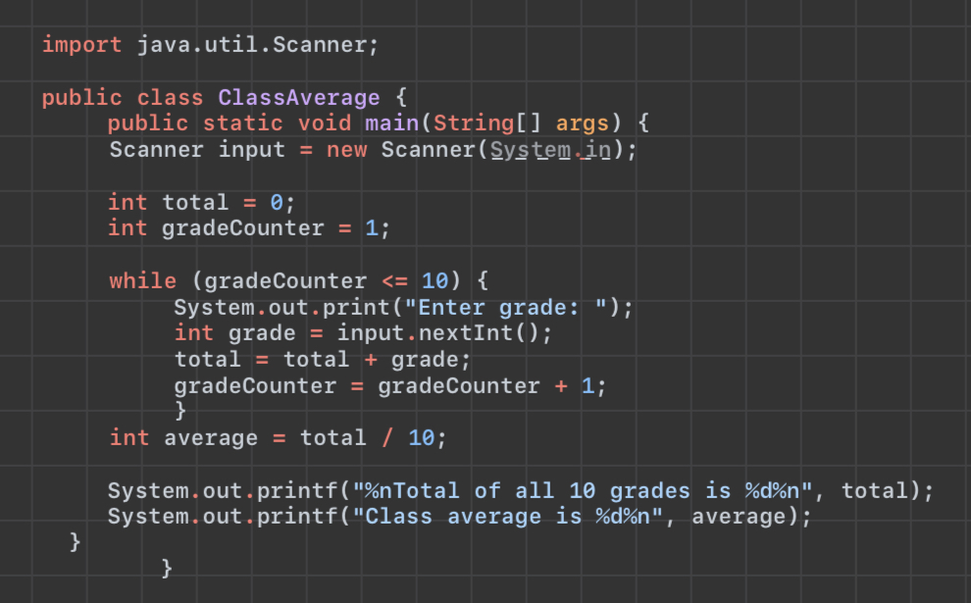

5a. public class OddNumber {

public static void main(String args[]) {

System.out.println("Odd numbers:");

for (int i = 1; i <= 100; i++) {

if (i % 2 != 0) {

System.out.print(i + " ");

}

}

}

5b. public class OddNumber {

public static void main(String[] args) {

int number = i;

while(i <= number)  {

System.out.print(i +" ");

i=i+2;

}

}

}

5c. public class OddNumber {

public static void main(String[] args) {

int number = i;

do {

System.out.print(i + “ “);

i=i+2;

} while(i <= number);

}

}

6. constructor

7a. import java.util.Scanner;

public class Name {

public static void main (String[] args) {

Scanner input = new Scanner(System.in);

System.out.println(“Enter your full name (F, MI, L)”);

String name = input.nextString();

System.out.println(name);

7b. import java.util.Scanner;

public class Name {

public static void main (String[] args) {

Scanner input = new Scanner(System.in);

System.out.println(“Enter your full name (F, MI, L)”);

String name = input.nextString();

System.out.println(“Enter two numbers”);

int num1 = input.nextInt();

int num2 = input.nextInt();

int sum = num1 + num2;

System.out.println(sum);

System.out.println(name);

8. import java.util.Scanner;

public class Number {

public static void main (String[] args) {

Scanner input = new Scanner(System.in);

System.out.println(“Enter three integers”);

int num1 = input.nextInt();

int num2 = input.nextInt();

int num3 = input.nextInt();

int max = num1;

if (num2 > max) max = num2;

if (num3 > max) max = num3:

System.out.println(max);

9.

10. a) true

b) false

c) true

d) false

e) true

11. a) Circle c1 = new Circle(5);

Circle c2 = new Circle(7, “Red”);

b) Student s1 = new Student();

c) int[] a3 = new int[25];

12.

public class sum() {

int sum = 0;

for (int i = 0; i < qArray.length; i++)

sum += qArray[i];

return sum;

}

public class Average(){

public class QArray {

public static void main(String[] args) {

int[] qArray = new int[100];

qArray = { 1, 3, 5, 7, 9, 11, 13, 15, 17, 19, 21, 23, 25, 27, 29, 31, 33, 35, 37, 39, 41, 43, 45, 47, 49, 51, 53, 55, 57, 59, 61, 63, 65, 67, 69, 71, 73, 75, 77, 79, 81, 83, 85, 87, 89, 91, 93, 95, 97, 99}

System.out.println("Sum of given array is " + sum());

double total = 0;

for(int i=0; i<qArray.length; i++){

total = total + qArray[i];

}

double average = total / qArray.length;

System.out.format("The average is: %.3f", average);

}

}